Exterior Angle Theorem

Definition
# Source: AI Source: Provided by: [Data Path: Persons Table -> ID Column: 1, Name_En Column: Motasem Essam] -> From: [ChatGPT] on [7/25/2026]
The Exterior Angle Theorem states that the measure of an exterior angle of a triangle is equal to the sum of the measures of its two non-adjacent interior angles.
If an exterior angle is formed by extending one side of a triangle, then:
$$\boxed{m∠ACD=m∠A+m∠B}$$
where $∠ACD$ is the exterior angle, and $∠A$ and $∠B$ are the two non-adjacent interior angles.
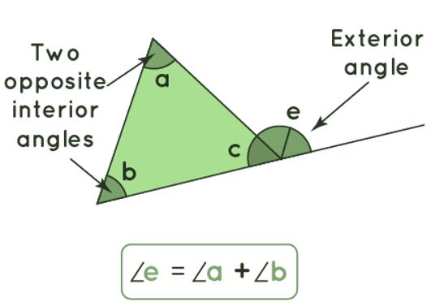
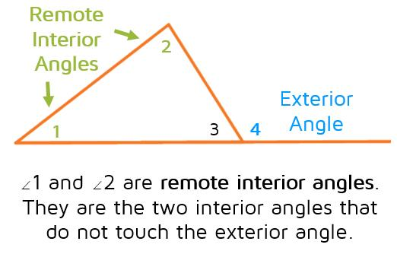
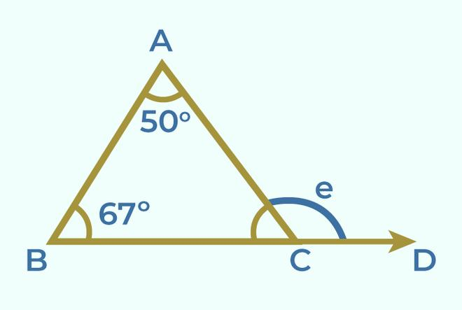
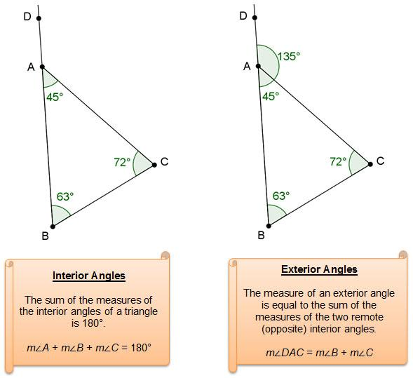

Purpose
# Source: AI Source: Provided by: [Data Path: Persons Table -> ID Column: 1, Name_En Column: Motasem Essam] -> From: [ChatGPT] on [7/25/2026]
The Exterior Angle Theorem is used to:
- Find an unknown exterior angle.
- Find an unknown interior angle.
- Establish relationships between triangle angles.
- Solve geometric problems.
- Verify angle measurements.
- Support proofs in geometry.
- Analyze triangles and polygon structures.

Exterior Angle
# Source: AI Source: Provided by: [Data Path: Persons Table -> ID Column: 1, Name_En Column: Motasem Essam] -> From: [ChatGPT] on [7/25/2026]
An exterior angle of a triangle is an angle formed by:
- One side of the triangle.
- The extension of an adjacent side.
For triangle $ABC$, if side $BC$ is extended to point $D$, then:
$$∠ACD$$
is an exterior angle.
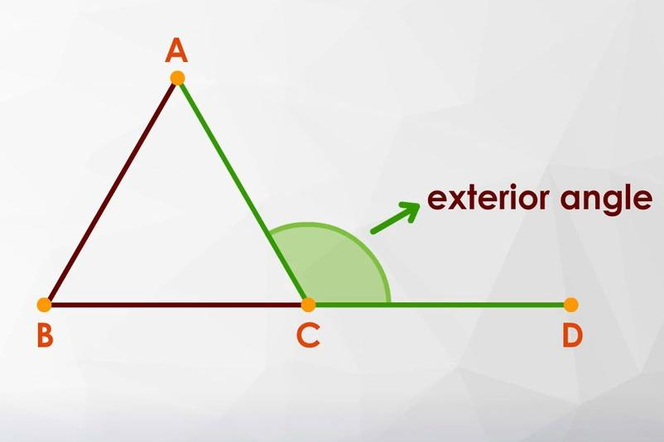
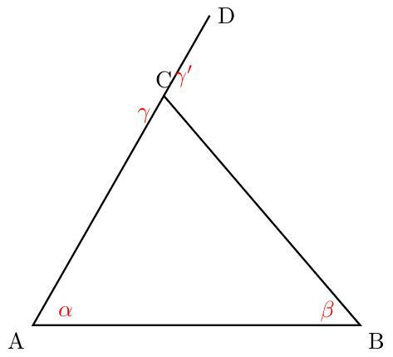
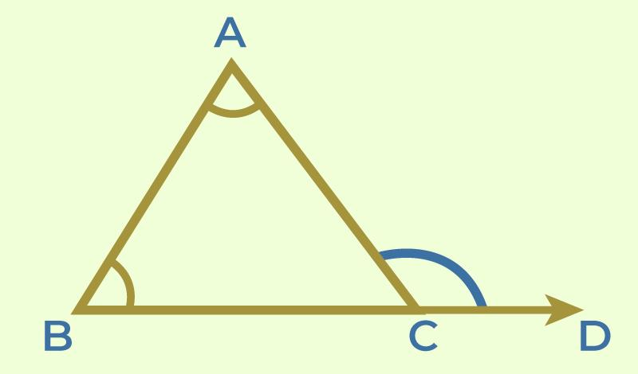

Interior Angles
# Source: AI Source: Provided by: [Data Path: Persons Table -> ID Column: 1, Name_En Column: Motasem Essam] -> From: [ChatGPT] on [7/25/2026]
Every triangle has three interior angles:
$$∠A, ∠B, ∠C$$
Their sum is:
$$\boxed{m∠A+m∠B+m∠C={180}^{∘}}$$

Remote Interior Angles
# Source: AI Source: Provided by: [Data Path: Persons Table -> ID Column: 1, Name_En Column: Motasem Essam] -> From: [ChatGPT] on [7/25/2026]
The two interior angles that are not adjacent to a particular exterior angle are called the remote interior angles.
For exterior angle $∠ACD$:
- $∠A$ is a remote interior angle.
- $∠B$ is a remote interior angle.
- $∠C$ is adjacent to the exterior angle.
Therefore:
$$\boxed{m∠ACD=m∠A+m∠B}$$

Mathematical Representation
# Source: AI Source: Provided by: [Data Path: Persons Table -> ID Column: 1, Name_En Column: Motasem Essam] -> From: [ChatGPT] on [7/25/2026]
For a triangle:
$$△ABC$$
with $BC$ extended to $D$:
$$\boxed{m∠ACD=m∠A+m∠B}$$
More generally:
$$\boxed{\text{Exterior Angle}={\text{Remote Interior Angle}}_{1}+{\text{Remote Interior Angle}}_{2}}$$

Example 1 — Finding an Exterior Angle
# Source: AI Source: Provided by: [Data Path: Persons Table -> ID Column: 1, Name_En Column: Motasem Essam] -> From: [ChatGPT] on [7/25/2026]
Suppose:
$$m∠A={50}^{∘}$$
and:
$$m∠B={70}^{∘}$$
Then:
$$m∠ACD={50}^{∘}+{70}^{∘} \\ \boxed{m∠ACD={120}^{∘}}$$
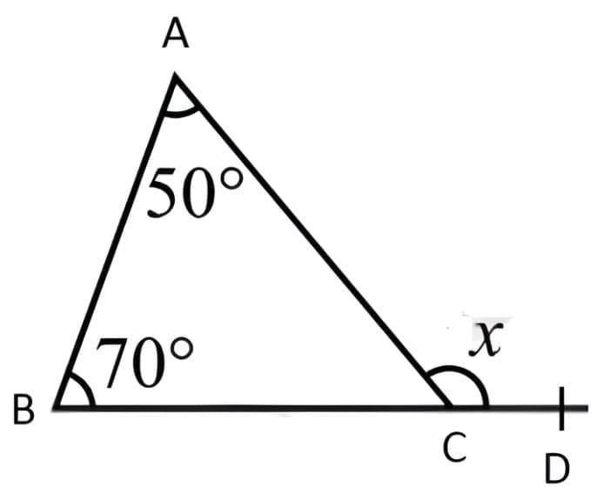
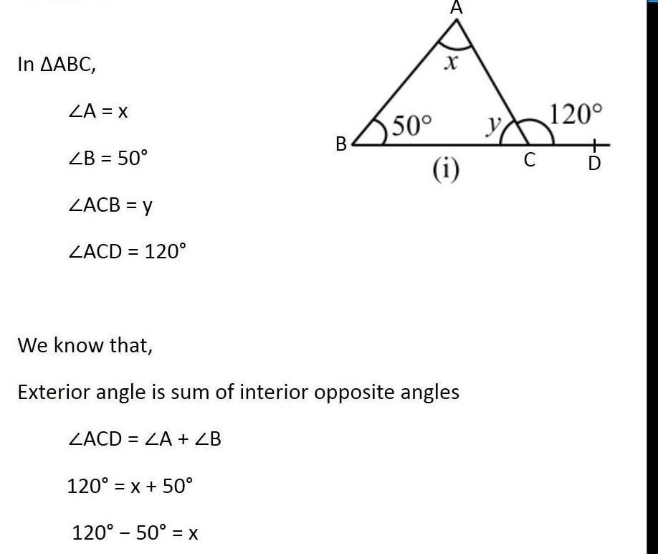
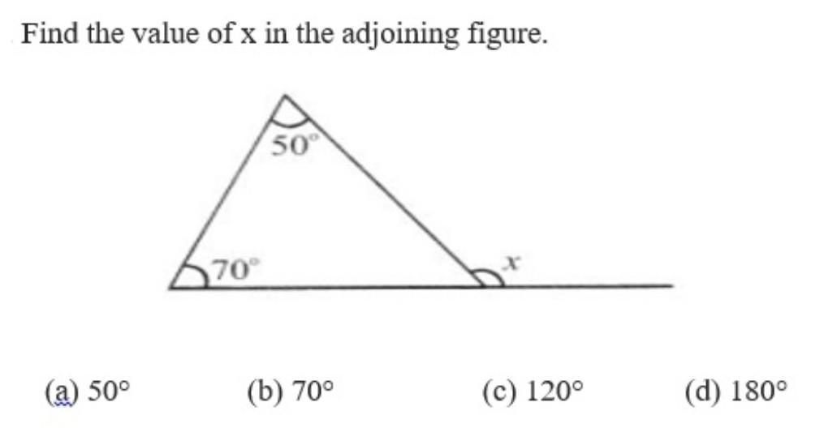

Example 2 — Finding a Missing Interior Angle
# Source: AI Source: Provided by: [Data Path: Persons Table -> ID Column: 1, Name_En Column: Motasem Essam] -> From: [ChatGPT] on [7/25/2026]
Suppose the exterior angle is:
$${120}^{∘}$$
and one remote interior angle is:
$${50}^{∘}$$
Using:
$${120}^{∘}={50}^{∘}+x$$
we get:
$$x={120}^{∘}-{50}^{∘}$$
Therefore:
$$\boxed{x={70}^{∘}}$$

Example 3 — Another Exterior Angle
# Source: AI Source: Provided by: [Data Path: Persons Table -> ID Column: 1, Name_En Column: Motasem Essam] -> From: [ChatGPT] on [7/25/2026]
Suppose:
$$m∠A={35}^{∘}$$
and:
$$m∠B={85}^{∘}$$
Then:
$$m∠ACD={35}^{∘}+{85}^{∘} \\ \boxed{m∠ACD={120}^{∘}}$$

Relationship with the Triangle Angle Sum
# Source: AI Source: Provided by: [Data Path: Persons Table -> ID Column: 1, Name_En Column: Motasem Essam] -> From: [ChatGPT] on [7/25/2026]
The Exterior Angle Theorem can be derived from the fact that the interior angles of a triangle sum to:
$${180}^{∘}$$
Suppose:
$$A+B+C={180}^{∘}$$
The exterior angle $E$ and interior angle $C$ form a straight angle:
$$E+C={180}^{∘}$$
Therefore:
$$E={180}^{∘}-C$$
Since:
$$A+B+C={180}^{∘}$$
we have:
$${180}^{∘}-C=A+B$$
Therefore:
$$\boxed{E=A+B}$$

Exterior Angle and Adjacent Interior Angle
# Source: AI Source: Provided by: [Data Path: Persons Table -> ID Column: 1, Name_En Column: Motasem Essam] -> From: [ChatGPT] on [7/25/2026]
An exterior angle and its adjacent interior angle form a linear pair.
Therefore, their measures add to:
$$\boxed{{180}^{∘}}$$
If:
$$m∠C={60}^{∘}$$
then its exterior angle is:
$${180}^{∘}-{60}^{∘}={120}^{∘}$$
Thus:
$$\boxed{E={180}^{∘}-C}$$
This is consistent with the Exterior Angle Theorem.

Exterior Angle Is Greater Than Either Remote Interior Angle
# Source: AI Source: Provided by: [Data Path: Persons Table -> ID Column: 1, Name_En Column: Motasem Essam] -> From: [ChatGPT] on [7/25/2026]
Because:
$$E=A+B$$
and the angles of a triangle are positive, it follows that:
$$\boxed{E>A}$$
and:
$$\boxed{E>B}$$
Therefore, an exterior angle of a triangle is always greater than either of its remote interior angles.
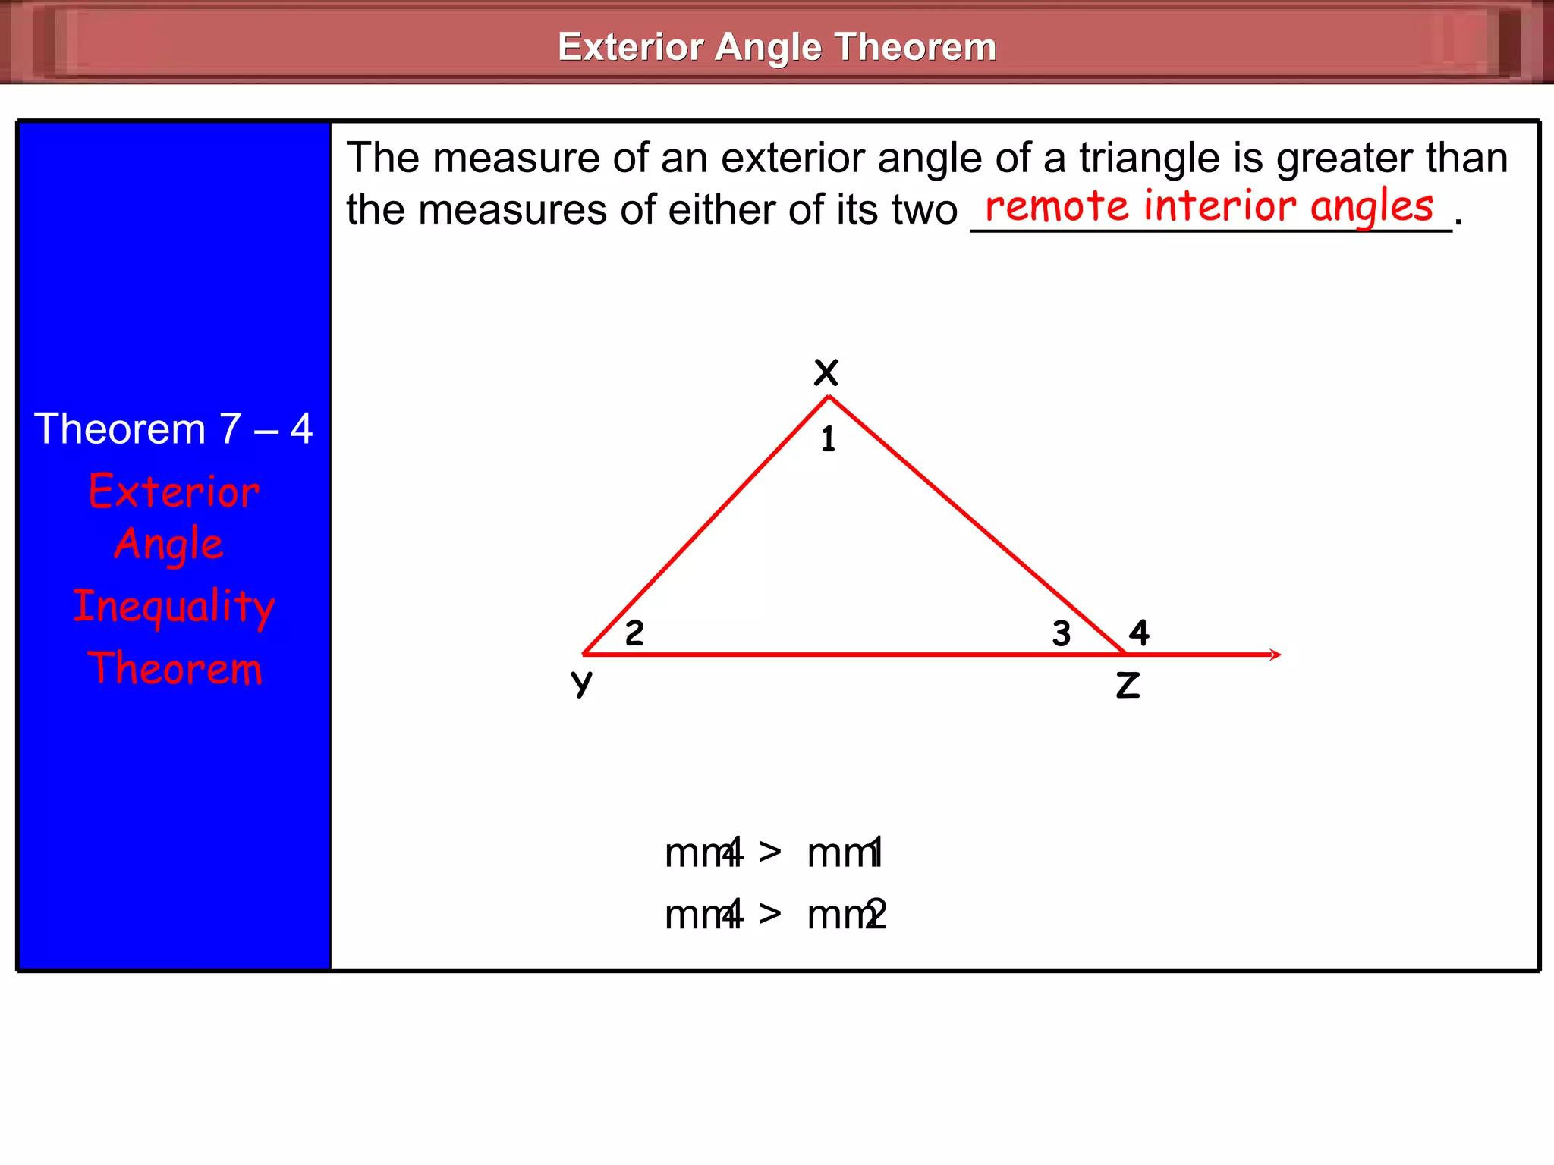
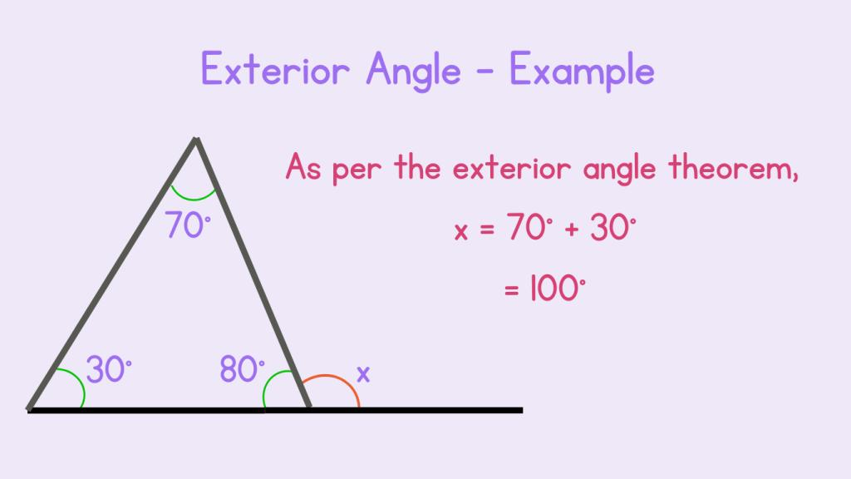
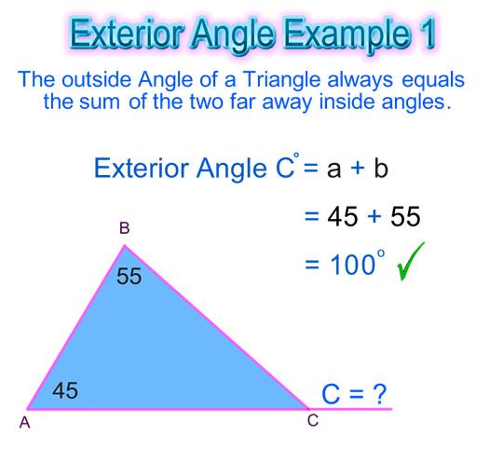
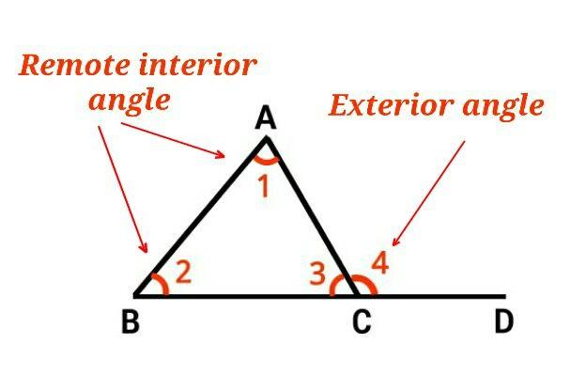

Exterior Angles of a Triangle
# Source: AI Source: Provided by: [Data Path: Persons Table -> ID Column: 1, Name_En Column: Motasem Essam] -> From: [ChatGPT] on [7/25/2026]
A triangle has three exterior angles, one associated with each vertex when a side is extended.
For example:
$$E_{A}, E_{B}, E_{C}$$
Each exterior angle equals the sum of the two remote interior angles.
For example:
$$\boxed{E_{A}=B+C} \\ \boxed{E_{B}=A+C} \\ \boxed{E_{C}=A+B}$$

Sum of Exterior Angles
# Source: AI Source: Provided by: [Data Path: Persons Table -> ID Column: 1, Name_En Column: Motasem Essam] -> From: [ChatGPT] on [7/25/2026]
Taking one exterior angle at each vertex and moving around the triangle, their sum is:
$$\boxed{{360}^{∘}}$$
For example, if the exterior angles are:
$${100}^{∘}, {120}^{∘}, {140}^{∘}$$
then:
$${100}^{∘}+{120}^{∘}+{140}^{∘}={360}^{∘}$$
Therefore:
$$\boxed{\text{Sum of exterior angles}={360}^{∘}}$$

Exterior Angle of a Regular Polygon
# Source: AI Source: Provided by: [Data Path: Persons Table -> ID Column: 1, Name_En Column: Motasem Essam] -> From: [ChatGPT] on [7/25/2026]
The concept extends beyond triangles.
For a regular polygon with $n$ sides, each exterior angle is:
$$\boxed{\frac{{360}^{∘}}{n}}$$
For example, a regular hexagon has:
$$\frac{{360}^{∘}}{6}={60}^{∘}$$
Therefore:
$$\boxed{\text{Each exterior angle of a regular hexagon}={60}^{∘}}$$
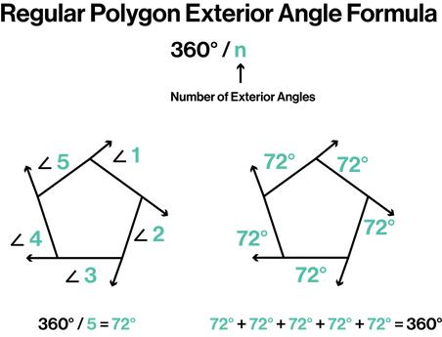
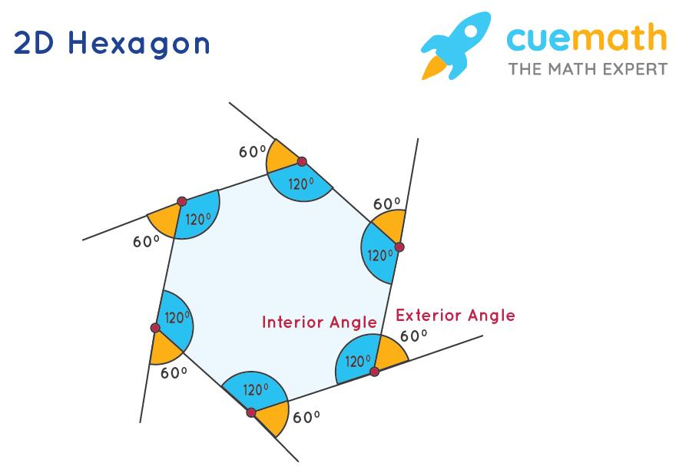
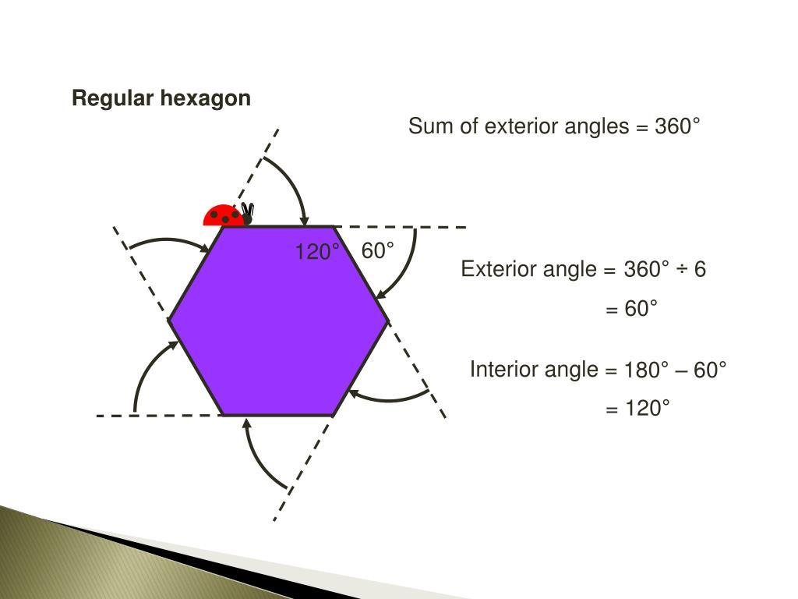
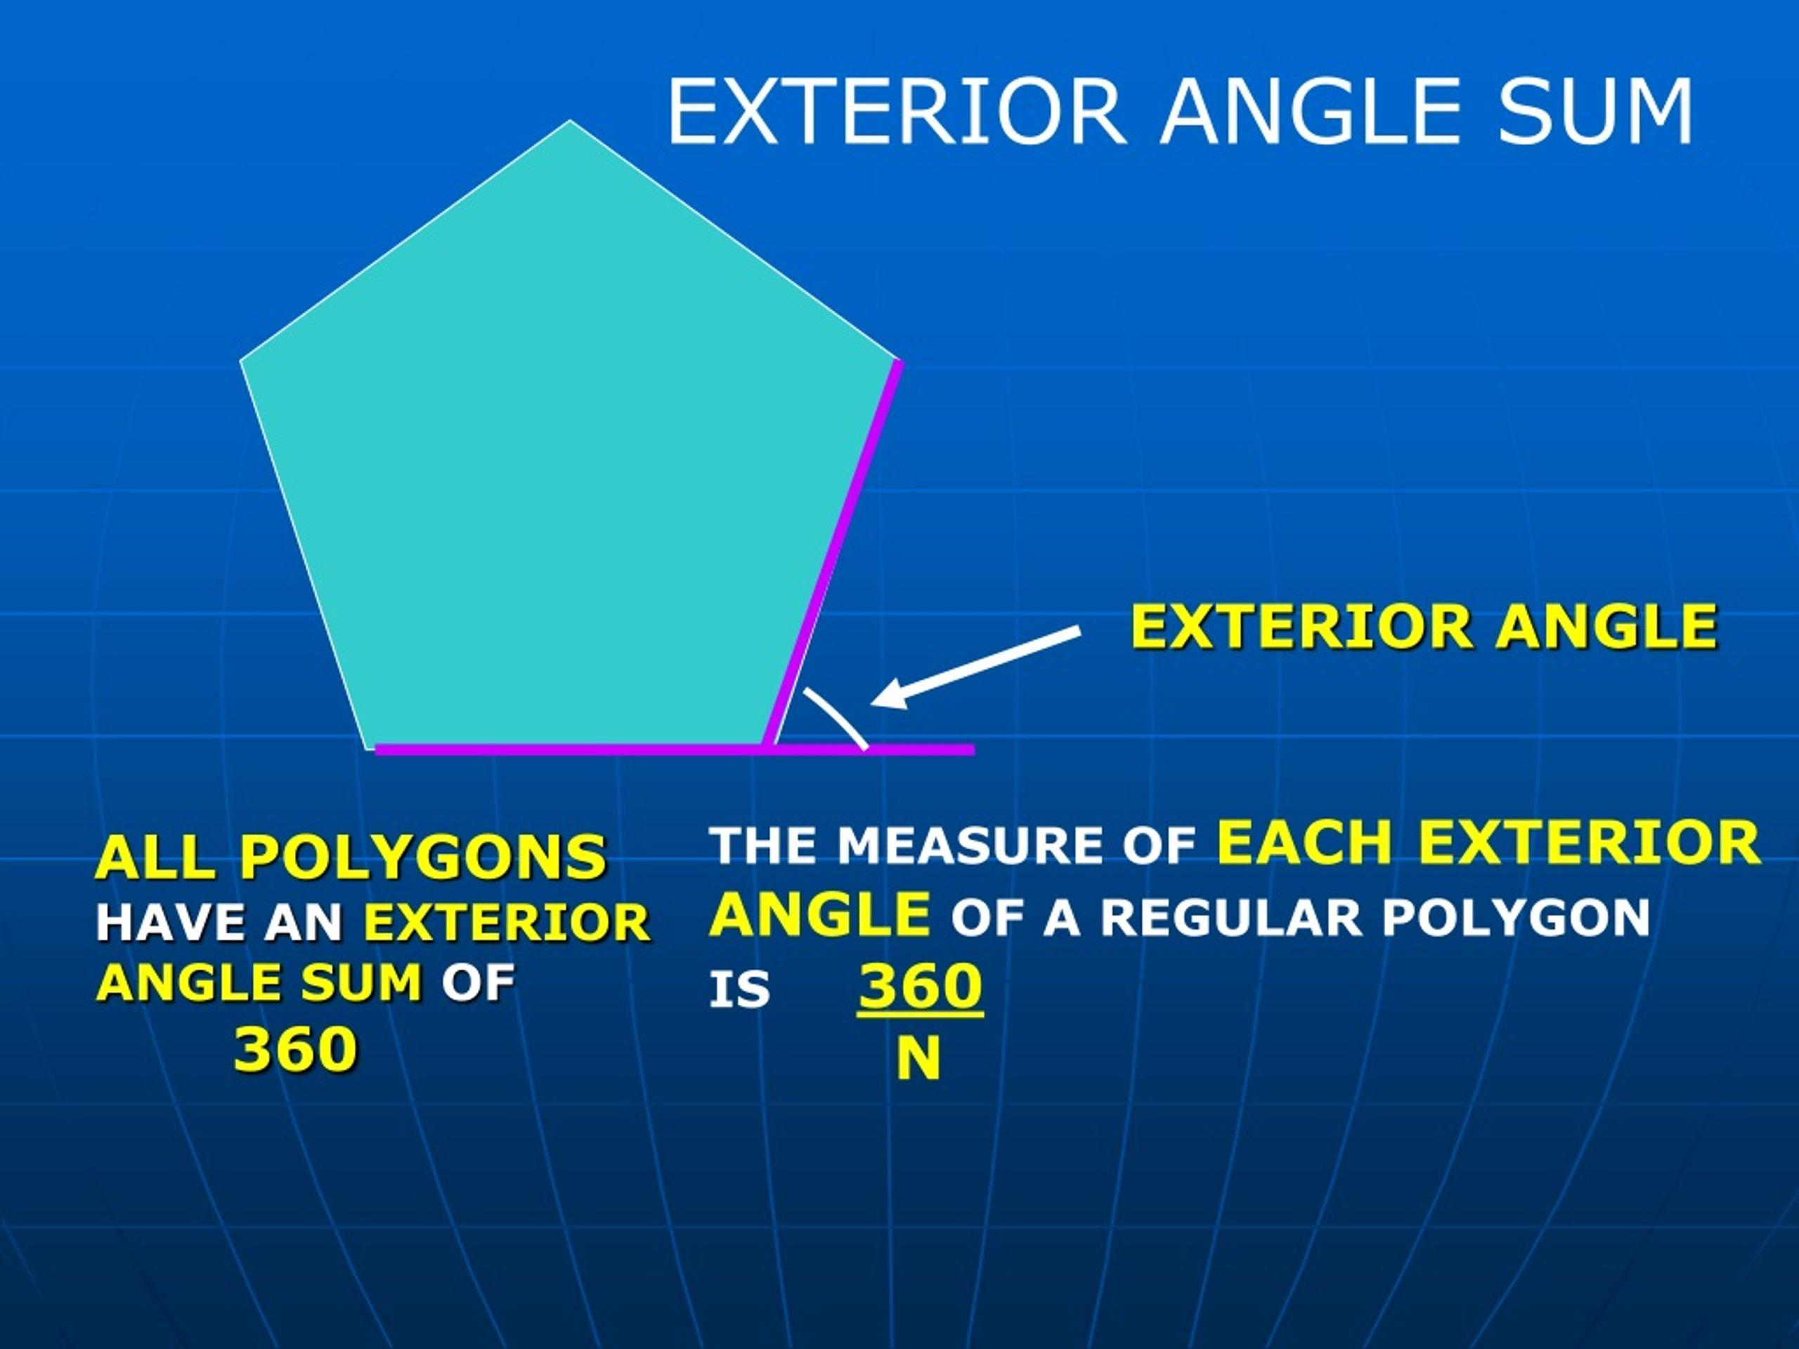
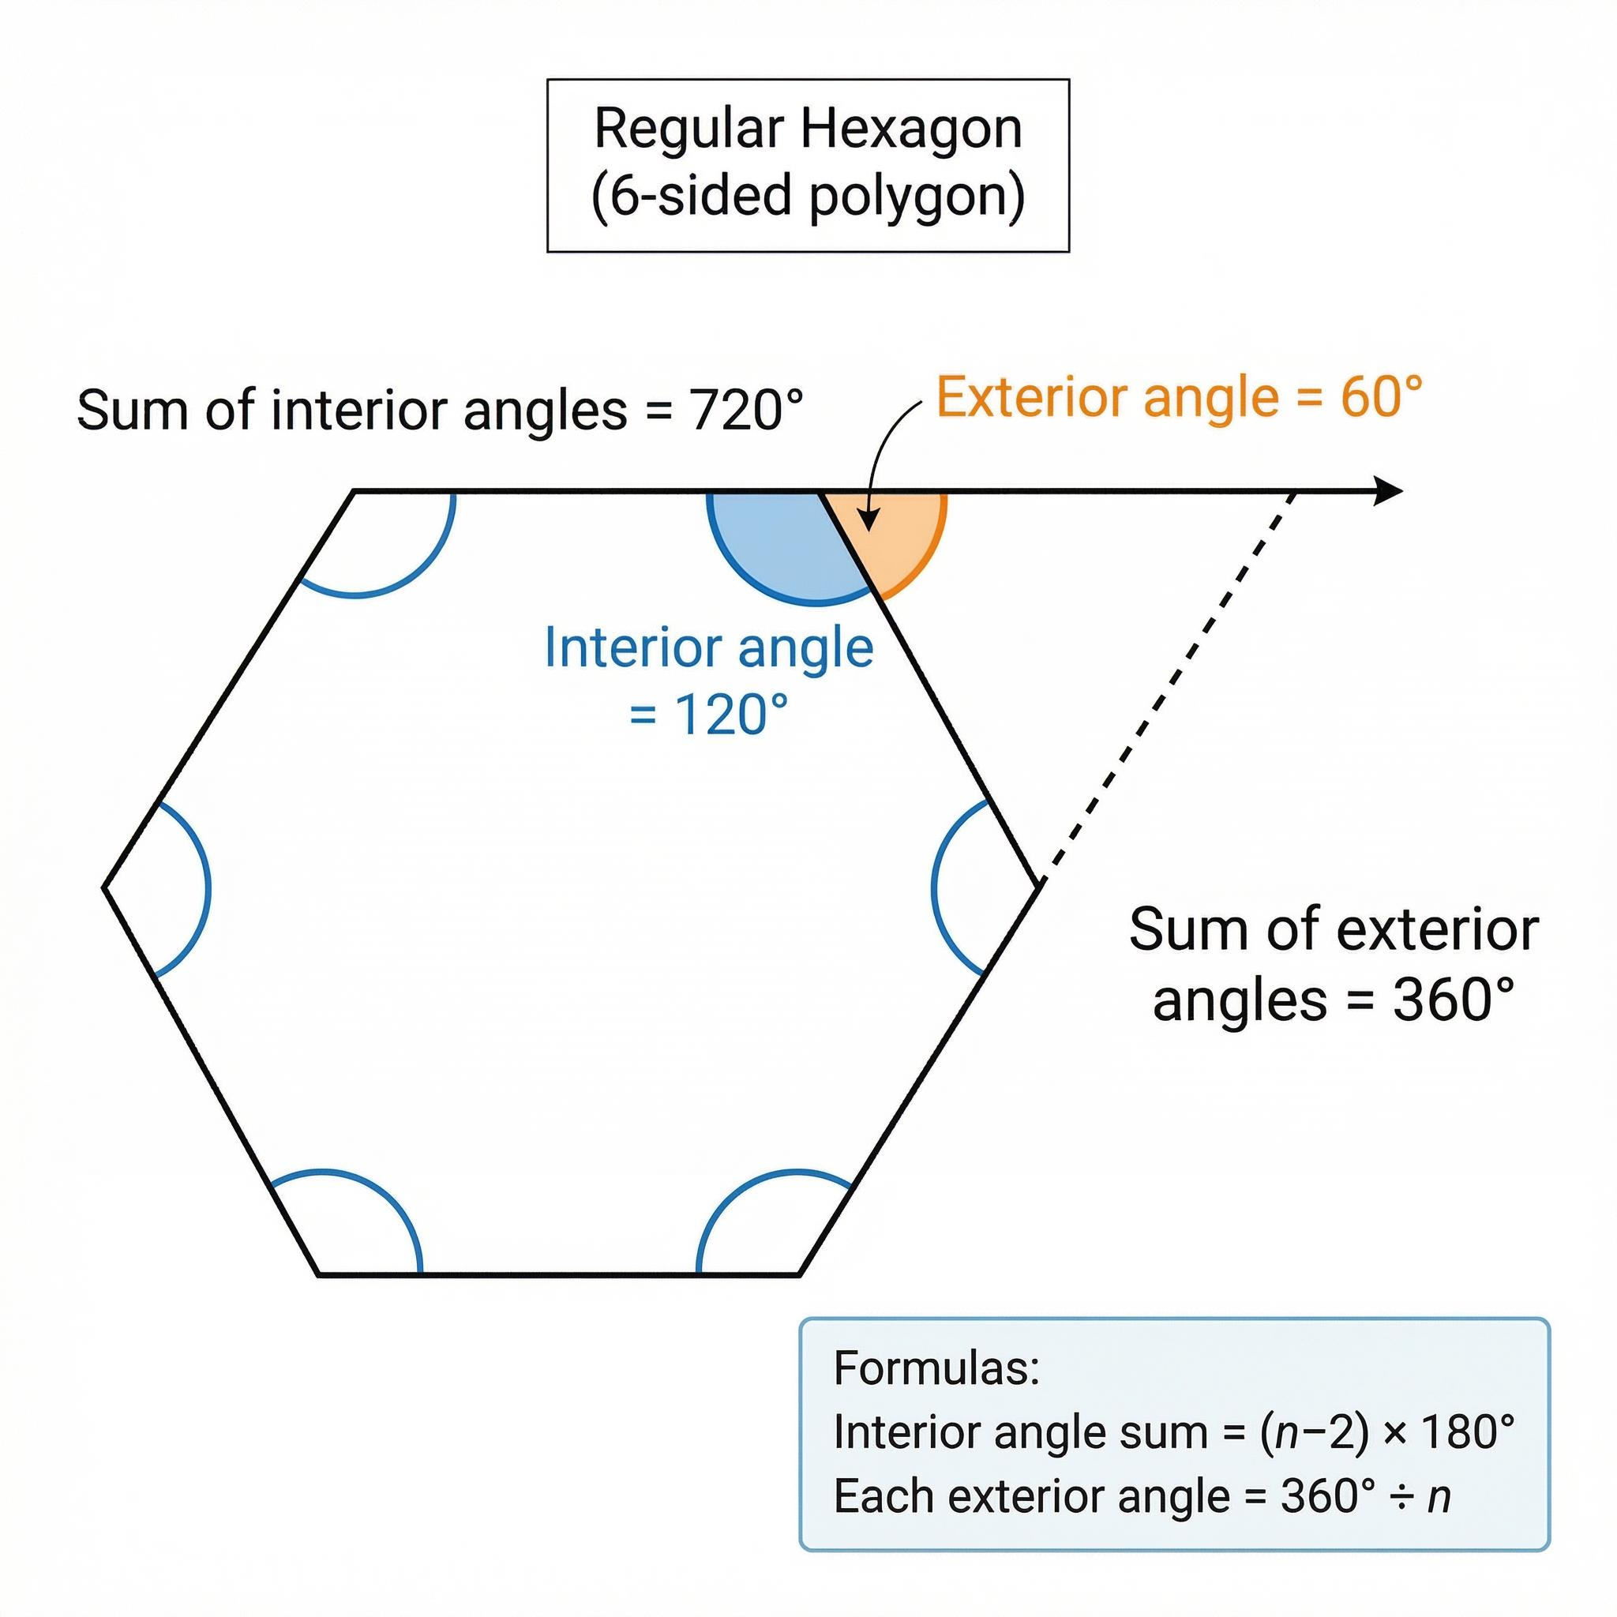

Exterior Angle vs Interior Angle
# Source: AI Source: Provided by: [Data Path: Persons Table -> ID Column: 1, Name_En Column: Motasem Essam] -> From: [ChatGPT] on [7/25/2026]
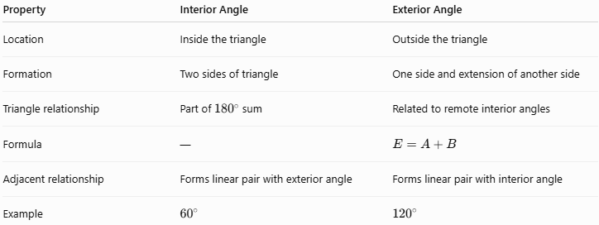
Property | Interior Angle | Exterior Angle
Location | Inside the triangle | Outside the triangle
Formation | Two sides of triangle | One side and extension of another side
Triangle relationship | Part of ${180}^{∘}$sum | Related to remote interior angles
Formula | — | $$E=A+B$$
Adjacent relationship | Forms linear pair with exterior angle | Forms linear pair with interior angle
Example | $${60}^{∘}$$ | $${120}^{∘}$$

Exterior Angle Theorem vs Triangle Angle Sum
# Source: AI Source: Provided by: [Data Path: Persons Table -> ID Column: 1, Name_En Column: Motasem Essam] -> From: [ChatGPT] on [7/25/2026]
These are related but different.
Triangle Angle Sum Theorem
$$\boxed{A+B+C={180}^{∘}}$$
It describes the sum of the three interior angles.
Exterior Angle Theorem
$$\boxed{E=A+B}$$
It describes an exterior angle in terms of the two remote interior angles.

Example 4 — Finding Three Angles
# Source: AI Source: Provided by: [Data Path: Persons Table -> ID Column: 1, Name_En Column: Motasem Essam] -> From: [ChatGPT] on [7/25/2026]
Suppose a triangle has:
$$A={40}^{∘} \\ B={65}^{∘}$$
Then:
$$C={180}^{∘}-\left({40}^{∘}+{65}^{∘}\right) \\ C={75}^{∘}$$
The exterior angle adjacent to $C$ is:
$$E={40}^{∘}+{65}^{∘} \\ \boxed{E={105}^{∘}}$$
Notice also:
$$E+C={105}^{∘}+{75}^{∘}={180}^{∘}$$

Proof of the Exterior Angle Theorem
# Source: AI Source: Provided by: [Data Path: Persons Table -> ID Column: 1, Name_En Column: Motasem Essam] -> From: [ChatGPT] on [7/25/2026]
Consider triangle $ABC$, with $BC$ extended to $D$.
The interior angles satisfy:
$$A+B+C={180}^{∘}$$
The exterior angle $E$ and $C$ form a straight angle:
$$E+C={180}^{∘}$$
Therefore:
$$E={180}^{∘}-C$$
From the triangle angle sum:
$$A+B={180}^{∘}-C$$
Thus:
$$\boxed{E=A+B}$$
Therefore, the exterior angle equals the sum of the two remote interior angles.

Real-World Applications
# Source: AI Source: Provided by: [Data Path: Persons Table -> ID Column: 1, Name_En Column: Motasem Essam] -> From: [ChatGPT] on [7/25/2026]
The Exterior Angle Theorem can be useful in:
- Architecture.
- Construction.
- Engineering.
- Surveying.
- Structural design.
- Computer graphics.
- CAD.
- Robotics.
- Navigation.
- Geometry education.
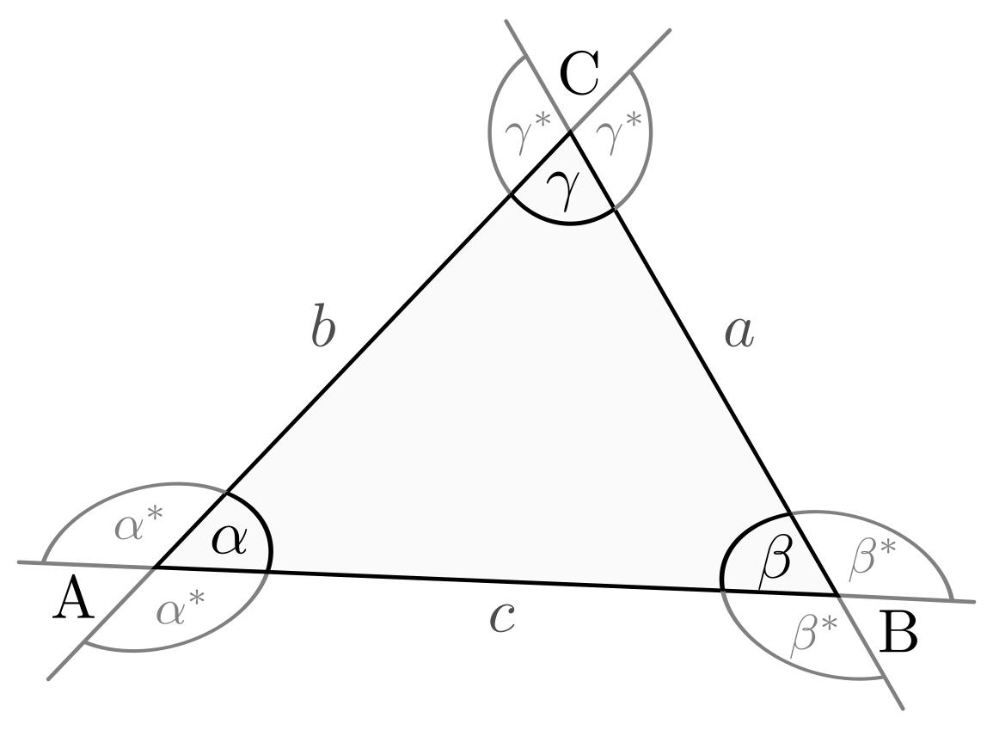

Applications
# Source: AI Source: Provided by: [Data Path: Persons Table -> ID Column: 1, Name_En Column: Motasem Essam] -> From: [ChatGPT] on [7/25/2026]
The theorem is important in:
- Plane Geometry
- Triangle Geometry
- Euclidean Geometry
- Polygon Geometry
- Trigonometry
- Coordinate Geometry
- Architecture
- Engineering
- Surveying
- CAD
- Computer Graphics

Advantages
# Source: AI Source: Provided by: [Data Path: Persons Table -> ID Column: 1, Name_En Column: Motasem Essam] -> From: [ChatGPT] on [7/25/2026]
Studying the Exterior Angle Theorem helps to:
- Calculate unknown angles quickly.
- Understand relationships between interior and exterior angles.
- Solve triangle problems.
- Support geometric proofs.
- Analyze polygon angles.
- Simplify complex angle calculations.

Limitations
# Source: AI Source: Provided by: [Data Path: Persons Table -> ID Column: 1, Name_En Column: Motasem Essam] -> From: [ChatGPT] on [7/25/2026]
The Exterior Angle Theorem:
- In its standard form applies to triangles.
- Requires correctly identifying the two remote interior angles.
- Applies to an exterior angle formed by extending a side of the triangle.
- Does not directly determine side lengths.
- Should not be confused with the exterior-angle sum of a polygon.

Comparison with Related Theorems
# Source: AI Source: Provided by: [Data Path: Persons Table -> ID Column: 1, Name_En Column: Motasem Essam] -> From: [ChatGPT] on [7/25/2026]
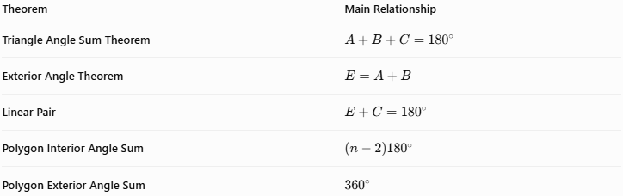
Theorem | Main Relationship
Triangle Angle Sum Theorem | $$A+B+C={180}^{∘}$$
Exterior Angle Theorem | $$E=A+B$$
Linear Pair | $$E+C={180}^{∘}$$
Polygon Interior Angle Sum | $$\left(n-2\right){180}^{∘}$$
Polygon Exterior Angle Sum | $${360}^{∘}$$

Key Points
# Source: AI Source: Provided by: [Data Path: Persons Table -> ID Column: 1, Name_En Column: Motasem Essam] -> From: [ChatGPT] on [7/25/2026]
- An exterior angle is formed by extending one side of a triangle.
- The two non-adjacent interior angles are called remote interior angles.
- The Exterior Angle Theorem states:
$$\boxed{E=A+B}$$
- An exterior angle equals the sum of its two remote interior angles.
- An exterior angle and its adjacent interior angle form a linear pair:
$$\boxed{E+C={180}^{∘}}$$
- An exterior angle is greater than either remote interior angle individually.
- The exterior angles of a triangle sum to:
$$\boxed{{360}^{∘}}$$
- For a regular polygon:
$$\boxed{E=\frac{{360}^{∘}}{n}}$$

Conclusion
# Source: AI Source: Provided by: [Data Path: Persons Table -> ID Column: 1, Name_En Column: Motasem Essam] -> From: [ChatGPT] on [7/25/2026]
The Exterior Angle Theorem establishes an important relationship between the angles of a triangle. It states that the measure of an exterior angle is equal to the sum of the measures of the two remote interior angles:
$$\boxed{E=A+B}$$
The theorem follows directly from the Triangle Angle Sum Theorem and the fact that an exterior angle and its adjacent interior angle form a straight angle. It provides an efficient method for finding unknown angles and forms an important foundation for the study of triangles, polygons, geometric proofs, surveying, engineering, architecture, CAD, and computer graphics.

